Disclosure by Institutions running AICTE approved MMS programmes to be included in their respective Information Brochure, displayed on their website and to be submitted to AICTE every year latest by 30th April together with its URL
The following information is to be given in the Information Brochure besides being hosted on the Institution’s official Website.
“The information has been provided by the concerned institution and the onus of authenticity lies
with the institution and not on AICTE.”

I. Name of the Institution

Name | BHARATI VIDYAPEETH’S INSTITUTE OF MANAGEMENT STUDIES & RESEARCH
Address | Permanent Location as approved by AICTE | Temporary Location (if applicable)
 | Sector-8,C.B.D., Belapur, Navi Mumbai-400 614 | Not Applicable
Village | - | -
Taluka | - | -
District | Thane | -
Pin Code | 400 614 | -
State | Maharashtra | -
STD Code | 022 | Phone No: 27572433,27562582
Fax No. | 27571182 | E-Mail: director@bvimsr.com
Web site | www.bvimsr.com

Name & Address of the Director
Name | DR. DATTAJIRAO Y. PATIL
Designation | DIRECTOR | Qualification & Experience  B.Sc. M.B.A. Ph.D |  | Highest Degree | Specialization | Total  Experience
Designation | DIRECTOR |  |  | M.B.A. Ph.D | Marketing | 32 Yrs
STD Code | 022 | Phone No. (O) |  | 27562582 | Fax No. 27571182
STD Code | 022 | Phone No. (R) |  | 27570711 | Fax No.
E-Mail | director@bvimsr.com |  | Mobile Phone | 09820424924

- Governance
Members of the Board of Governors’ of Bharati Vidyapeeth is as follows:
Founder – Hon’ble Dr. Patangrao Kadam
OFFICERS
Vice-President
Hon’ble Shri. Indrajeet Mohite

Chairman Secretary
Hon’ble Shri. Anandrao B. Patil Hon’ble Dr. Vishwajeet P. Kadam

Joint Secretary Joint Secretary
Hon’ble Shri. V.B. Mhetre Hon’ble Dr. M.S. Sagare
Hon’ble Dr. K.D. Jadhav

EXECUTIVE COUNCIL
Founder Chairman
Hon’ble Dr. Patangrao Kadam Hon’ble Anandrao B. Patil

Secretary
Hon’ble Dr. Vishwajeet P. Kadam

MEMBERS
Hon’ble Dr. S.S. Kadam Hon’ble Dr. S.R. Suryawanshi
Hon’ble Shri. V.B. Mhetre Hon’ble Shri. S. M. Dingane

MANAGING COUNCIL
Founder
Hon’ble Dr. Patangrao Kadam
Chairman Secretary
Hon’ble Shri. Anandrao Patil Hon’ble Dr.Vishwajeet P. Kadam

MEMBERS
Hon’ble Dr. S.S. Kadam Hon’ble Dr.S.V. Kadvekar
Hon’ble Dr. S.R. Suryawanshi Hon’ble Dr.. K.D. Jadhav
Hon’ble Shri. S. M. Dingane Hon’ble Shri. B.D. Mane
Hon’ble Shri. V.B. Mhetre Hon’ble Dr. E. K. Bharucha
Hon’ble Shri. Vasantrao M. Mane Hon’ble Dr. Ravindra Kharat
Hon’ble Shri. Mohanrao S. Kadam Hon’ble Dr. D.Y. Patil
Hon’ble Dr. Indrajit Mohite Hon’ble Dr. Kalyani Diwekar
Hon’ble Dr. H.M. Kadam Hon’ble Shri. L.B, Lokhande
Hon’ble Dr. V.J. Kadam Hon’ble Mrs. S.A. Kulkarni
Hon’ble Shri. A.J. D’souza

Members of Academic Advisory Body:

The Academic advisory body of Bharati Vidyapeeth’s Institute of Management Studies & Research, Navi Mumbai include the following members:
Name | Designation | Years of experience
Dr. Shivajirao Kadam | Vice Chancellor, Bharati Vidyapeeth Deemed University | 32 years
Dr. U. Bhoite | Executive Director & Formal Vice Chancellor Bharati Vidyapeeth Deemed Univesity | 42 years
Dr. K. D. Jadhav | Principle, Y.M. College, Bharati Vidyapeeth Deemed | 32 years
Mr. Arup Gupta | GM- HR DNA | 27 years
Dr. B.R.Singh | Ex. Group Director Ispat India Ltd. | 32 years
Dr. D.Y.Patil | Director, BVIMSR | 32 years
Frequency of the Board Meetings and Academic Advisory Body Meetings:

The Board Meetings and Academic Advisory Body Meetings are held twice a year.

Organizational chart and processes:

Board of Governors of Bharati Vidyapeeth

Governing Body of Bharati Vidyapeeth’s Institute of Management Studies & Research

Purchase Finance Building and works Academic Advisory Body
Committee Committee committee

Director of the Institute

Staff

Teaching (Sub-committees) Non-teaching

Students Committee

Nature and Extent of involvement of faculty and students in academic affairs/improvements:

We, at our institute organize training programmes and workshops for our students periodically in order to improve their skills and knowledge base. Eminent personality from academics and industry are invited to share their insights on a wide range of subjects beyond the curriculum.
In order to build a close affinity between our faculty and students, we have devised a system of assigning faculties as mentors for the students. Each faculty is allotted a set a ten students, who communicate with one another or a daily basis. The students are encouraged to discuss not only their difficulties relating to studies but also to discuss their personal problems. This goes a long way in guiding the students in taking right decisions.
Soft skills supplement technical skills. The two transform a student into a well-rounded individual ready to take up the challenges of the corporate world. Towards meeting this objective, we screen movies highlighting managerial skills, leadership qualities, team efforts etc.
In keeping with the ideology of “sound mind in a sound body”, we have started meditative technique of ‘Anapana’ in the institute. It is practiced by students which in turn enhances their concentration and alertness.
Yoga sessions are also conducted in the campus to promote physical fitness and mental sharpness.
In order to develop social consciousness and philanthropic qualities among the students, the institute has taken initiative to contribute towards social responsibility through YMCA.

Committees for the academic year 2015 – 2016
- Class Coordinators
MMS – Semester I (A) - Ms. Mona Sinha
MMS – Semester I (B) - Ms. Asmat Ara Shaikh
MMS – Semester III (A) - Dr. Anjali Kalse
MMS – Semester III (B) - Ms. Priyeta Priyadarshini

- Examination Committee
Committee Members - Dr. D.Y. Patil
Ms. Veena Chavan

3) Cultural Committee
Committee Members - Ms. Asmat Ara Shaikh
Ms. Sonali Athawale

4) Library Committee
Committee Members - Dr. Govind Shinde
Ms. Mukta Khapre

5) PDP Committee
Committee Members - Dr. Sharukh Tara
Mr. Suresh Patil
Dr. Amol Gore

6) Students Grievances Redressal Committee
Committee Members - Dr. D.Y.Patil
Ms. Mona Sinha
Ms. Varsha Gawli
Students Representative

7) Anti Ragging Committee
Committee Members - Dr. D.Y.Patil
Dr. Ashish Shirurkar – Practicing Physician
Mr. Shekhar Tore – Police Officer
Mr. C.B. Ligade – Reporter
Mr. Suresh Sharma – NGO
Dr. Anjali Kalse
Students Representative
Parent Representative
Mr. M.A.Kadam

8) Placement committee
Committee Members - Mr. Suresh Patil
Dr. Prachi Murkute
Ms. Sushma Patil
Ms. Varsha Gawli

9) Industrial Visit Committee
Committee Members - Dr. Sharukh Tara
Mr. Deepak Jakate

10) Seminar Committee
Committee Members - Mr. Kuldeep Bhalerao
Ms. Ambika Arvind

- Programmes

- Name of the Programmes approved by the AICTE : MMS, MFM, MMM, MHRDM, PGDBM

- Name of the Programmes accredited by the AICTE: Application is in process
- For each Programme the following details are to be given:
- Name of the course & Intake Capacity
Master of Management Studies (MMS) - 120
Master of Financial Management (MFM) – 60
Master of Marketing Management (MMM) – 60
Master of Human Resource Development Management (MHRDM) – 60
Post Graduate Diploma in Business Management (PGDBM) - 60

- Duration : MMS: 2 years full time course, MFM, MMM & MHRDM: 3 years part time course
- Cut off mark/rank for admission during the last two years for MMS Course:
2014 – 2015: 149
2015 – 2016: 86.446
- Fee : MMS - 1,75,000/- (Fee finalized by Shikshan Shulk Samiti. Govt. of Maharashtra)
MFM – 46,000/-
MMM – 46,000/-
MHRDM – 46,000/-
PGDBM – 2,00,000/-

- Placement Facilities -
The Institute has a separate Placement Cell backed by professionals from the industry who interact and guide students on a regular basis. The Cell has continuous contact with different organizations. Experts from the industry visit the campus and have interaction with the student community.
The Placement Cell constantly interacts with the top Executives in the Industry. It invites Corporate for Pre-Placement Talks with the students in the Institute. The Cell actively co-ordinates with Guest Faculty and invites experts from the Industry to share their experiences with the students.
It conducts Personality Development Programmes, Workshops and Seminars in consultation with faculty and students. It designs Placement Brochure with the co-ordination of the students. The Placement Brochures are sent to Companies and also to the Placement Agencies. Many Companies have dedicated placement agencies on their panel and don’t entertain direct contacts with the job-seekers.
The persons attached to the Cell keep a close contact with the companies by visiting their HR Heads or CEO’s at regular intervals for placing the students in their respective organizations. It makes arrangement for conducting campus interviews for final year students and arranges summer placements for the first year students. It gives counseling to the students and guides them in making their summer projects and final projects.

- Campus placement in last three years with minimum salary, maximum salary and average salary
2013-2014
Minimum salary : Rs. 2.5 LPA
Average salary : Rs. 3.75 LPA
Maximum salary : Rs. 5.0 LPA

2014-2015
Minimum salary : Rs. 2.5 LPA
Average salary : Rs. 4.0 LPA
Maximum salary : Rs. 5.5 LPA

2015-2016
Minimum salary : Rs. 2.5 LPA
Average salary : Rs. 3.94 LPA
Maximum salary : Rs. 5.39 LPA

Name and duration of programme(s) having affiliation/collaboration with Foreign University(s)/Institution(s) and being run in the same Campus along with status of their AICTE approval. If there is foreign collaboration, give the following details: Not Applicable
- Details of the Foreign Institution / University: NOT APPLICABLE
    - Name of the University/Institution
    - Address
    - Website
    - Is the Institution / University Accredited in its Home Country
    - Ranking of the Institution / University in the Home Country
    - Whether the degree offered is equivalent to an Indian degree?
If yes, the name of the agency which has approved equivalence. If no, implications for students in terms of pursuit of higher studies in India and abroad and jobs both within and outside the country.
NOT APPLICABLE
- Nature of Collaboration
- Conditions of Collaboration
- Complete details of payment a student has to make to get the full benefits of collaboration.

  - For each Collaboration / affiliated Programme give the following: NOT APPLICABLE
    - Programme Focus
    - Number of seats
    - Admission Procedure
    - Fee
    - Placement Facility
    - Placement Records for last two years with minimum salary and average salary

      - Whether the Collaboration Programme is approved by AICTE? If not whether the Domestic / Foreign Institution has applied to AICTE for approval as required under notification no.37-3/Legal/2005 dated 16th May, 2005. NOT APPLICABLE

FACULTY :

Permanent Faculty: Bharati Vidyapeeth’s Institute of Management Studies & Research, Navi Mumbai
Sr.  No. | Name of the Core Faculty | Designation | Qualification | Date of Birth | Experience  a) Teaching  b) Industry  c) Research |  |  | Gross Total  Salary as on date with Basic & Grade Pay
 |  |  |  |  | a (yrs) | b (yrs) | c (yrs) | Gross Total  Salary as on date with Basic & Grade Pay
1 | Dr. D.Y.Patil | Director | B.Sc., MBA, Ph.D. | 19/11/1955 | 32 | 5 | 20 | 126287.00
2 | Mr. J.C.Sharma | Professor | M.Sc., M.Phil. | 23/10/1941 | 15 | 46 | 15 | 40000.00
3 | Dr. Sharukh Tara | Professor | M.Com, AICWA, LL.B., MCT, Ph.D. | 29/04/1954 | 25 | 13 | 5 | 105583.00
4 | Dr. Anjali Kalse | Professor | B.Sc., MIRPM, Ph.D. | 9/05/1970 | 16 | 2 | 0 | 117936.00
5 | Dr. Anil Kumar Garg | Professor | MBA, Ph.D. | 13/06/1964 | 12 | 10 | 3 | 105583.00
6 | Mr. Suresh Patil | Professor | M.Com., PGDPM, PGDTD | 19/07/1959 | 20 | 18 | 0 | 101726.00
7 | Dr. Amol Gore | Professor | M.S. (Seden), Dr.Sc. (Tech),  Post-Docorate (France) | 14/07/1975 | 4 | 11 | 7 | 103655.00
8 | Dr. Govind Shinde | Associate Professor | M.Com, GD&CA, MBA, Ph.D. | 8/06/1971 | 16 | 1 | 0 | 76658.00
9 | Ms. Mona Sinha | Associate Professor | MA, MBA | 16/02/1966 | 13 | 2 | 0 | 72255.00
10 | Mr. Deepak Jakate | Associate Professor | B.Tech., PGDM (IIM-B) | 27/05/1965 | 19 | 7 | 0 | 58873.00
11 | Dr. Kamini Khanna | Associate Professor | M.Sc., M.Phil., Ph.D. | 10/12/1977 | 6 | 6 | 4 | 72255.00
12 | Ms. Veena Chavan | Assistant Professor | BCA, MBA | 13/09/1980 | 3 | 9 | 0 | 53782.00
13 | Ms. Asmat Ara Shaikh | Assistant Professor | BA, MBA | 30/06/1977 | 7 | 0 | 0 | 47762.00
14 | Ms. Mukta Khapre | Assistant Professor | B.Pharm., MBA | 29/06/1985 | 6 | 2 | 0 | 49196.00
15 | Mr. Kuldeep Bhalerao | Assistant Professor | B.Tech., MBA | 10/11/1979 | 4 | 7 | 0 | 49196.00
16 | Ms. Priyeta Priyadarshini | Assistant Professor | B.Sc., PGDIM (XISS-Ranchi), M.Phil. | 4/08/1982 | 7 | 0 | 0 | 46368.00
17 | Ms. Sonali Athawale | Assistant Professor | M.Com., MBA | 28/04/1979 | 3 | 7 | 0 | 49196.00
18 | Ms.Ambika Arvind | Assistant Professor | MA, M.Phil. | 11/02/1957 | 35 | 0 | 0 | 46368.00
19 | Mr. Rahul Mahadik | Assistant Professor | B.Com., MMS | 5/06/1986 | 5 | 1 | 0 | 47762.00
20 | Ms. Pranali Timse | Assistant Professor | BHMT, MMS | 2/02/1986 | 5 | 0 | 0 | 47762.00
21 | Mr. Thuse Ashish | Assistant Professor | B.Com., MMS | 16/06/1988 | 5 | 0 | 0 | 47762.00
22 | Mr. Adityaraj Desai | Assistant Professor | BBA, MMS | 11/06/1987 | 2 | 4 | 0 | 47762.00
23 | Dr. Hemshweta Rathore | Assistant Professor | B.Com., MFC, Ph.D. | 30/07/1981 | 2 | 0 | 1 | 45015.00
24 | Dr. Prachi Murkute | Assistant Professor | B.Com., PGDBM, MMS & Ph.D. | 4/01/1974 | 7 | 4 | 1 | 45015.00
25 | Ms. Sushma Patil | Assistant Professor | B.Pharm., MBA | 6/10/1979 | 6 | 6 | 0 | 45015.00
26 | Ms. Mrinal Phalle | Assistant Professor | B.Sc., MMS | 28/01/1978 | 7 | 0 | 0 | 45015.00
27 | Mr. Ramchandra Deokar | Assistant Professor | B.Sc., M.Sc., MFM | 6/01/1971 | 20 | 0 | 0 | 47762.00
28 | Mr. Rajaram Kadam | Assistant Professor | B.Sc., M.Sc., MFM | 24/11/1970 | 20 | 0 | 0 | 47762.00

Visiting Faculty: Bharati Vidyapeeth’s Institute of Management Studies & Research, Navi
Mumbai
Sr. No. | Name of the Visiting Faculty | Academic Qualification | Work Experience In Years
1 | Mr. Allan Joseph Collaco | MA (PM&IR) | 37 years
2 | Mr. A. B. Pawar | M.Sc. Maths | 26 years
3 | Mr. Jitendra Singh | B.Tech. (Mechanical), MBA | 25 years
4 | Dr. Manohar Pandit | M.A. M.D. DIM | 43 years
5 | Mr. R Phadake | B.Com, M.Com, CA | 28 years
6 | Mr. Sugam Chaubal | B.Com, MBA | 28 years
7 | Mr. Alok Govil | B.Tech., PGDBM, PGDFC | 39 years
8 | Mr. Ashok Thapar | B.Sc., BMM, MBA | 35 years
9 | Ms. Asha Phadke | M.Com, CA | 24 years
10 | Mr. B.S. Pai | B.E. (Electrical) | 51 years
11 | Mr. Farrok Mistry | M.Com., MMS, CAIIB | 50 years
12 | Mr. Jafarali Sayyad | HSK Level 4 (Mandarin Language), BA | 3 years
13 | Mr. K.K.Gupta | MA (Economics) | 43 years
14 | Mr. K.R. Srinivasan | B.E.(EXTC), Project Management (IIT Bombay) | 39 years
15 | Mr. Kapil Tondon | M.Tech.(Chemical), PGDBM | 42 years
16 | Dr. Logakanthi Subramanian | M.Sc., M.Phil., Ph.D. NET | 8 years
17 | Mr. Madan Mohan | B.Sc., BE., MBA | 43 years
18 | Mr. Nadeem Merchant | B.Sc., MBA, Ph.D. | 23 years
19 | Mr.Prakash Gehani | B.Pharm., LLM | 11 years
20 | Dr. Purvi Pujari | BA, MA, Ph.D., JRE (NET) | 9 years
21 | Dr. Shivaji Sawant | BE (Mechanical), ME (Production-VJIT), Ph.D. | 35 years
22 | Ms. Shilpi Agarwal | B.Com., M.Com., MA, B.Ed., MBA, FRM, CA | 16 years

Permanent Faculty: Student Ratio: 1:7

Number of faculty employed and left during the last three years:

NUMBER OF FACULTY EMPLOYED DURING THE LAST TWO YEARS : 39
NUMBER OF FACULTY WHO LEFT DURING THE LAST TWO YEARS : 11

Profile of Director/Principal with qualifications, total experience, age and duration of employment at the institute concerned:

PROFILE of Director:
Dr. Dattajirao Y. Patil, Director
Qualification: B.Sc., MBA, Ph.D.
Professinal Experience: 32 years of Academic Administration & Industry
Current Position: Management Council Member & member of Senate, University of Mumbai, Former President – Association of Indian Management Schools (AIMS), Secretary-Forum of Management Institutions, University of Mumbai.
Research & Consultancy: Published and presented more than 30 papers in National & International Conferences & Refereed International & National Journals. Guided 12 candidates for Ph.D. successfully.

VI. Fee:
- Details of fee, as approved by State fee Committee, for the Institution.
The following fee structure is approved by the Shikshan Shulka Samiti (Government of Maharashtra) for the MMS Course in this college- Rs. 1,75,000/-

SSS(H&T) – 8th October 2015 Final Fee – 2015-16 Date : 16th October 2015
Final Fee for Higher and Technical Courses for the Academic Year 2015-16.
Sr. No. | Instiute Code | Institute Name | Date of the Meeting | Tuition Fee | Development Fee | Total Fee
7 | MB3101 | Bharati Vidyapeeth’s Institue of  Management Studies & Reseach, Belapur, Navi Mumbai | Date : 8th October 2015 | 159091 | 15909 | 175000

- Time schedule for payment of fee for the entire programme:
Students seeking admission to the M.M.S. Course are supposed to pay the entire annual fee at the time of admission.

- No. of Fee waivers granted with amount and name of students:
No fee waivers have been granted in the recent past.

- Number of scholarship offered by the institute, duration and amount: Scholarship was offered
by Social Welfare Department to SC, ST, OBC, DT, NT, VJ, SBC students

- Criteria for fee waivers/scholarship: N. A.

- Estimated cost of Boarding and Lodging in Hostels:
The accommodation in the hostel for Boys – 250 seats & for Girls – 250 Nos. Fees for the hostel is as follows (Hostel Facility shared with Bharati Vidyapeeth’s other Institutes)
Hostel fee - Rs. 75000/- p.a.

- ADMISSION:

  - Number of seats sanctioned with the year of approval
Academic year : 2013 – 2014 : 120
2014 – 2015 : 120

  - Number of students admitted under various categories each year in the last three years

Category | Year |  |  | Year |  |  | Year
Category | 2013-2014 |  |  | 2014-2015 |  |  | 2015-2016
Category | M | F | T | M | F | T | M | F | T
State Quota | 26 | 17 | 43 | 14 | 07 | 21 | 26 | 26 | 52
Outside State Quota | 06 | 03 | 09 | 10 | 06 | 16 | 03 | 02 | 05
NRI Quota | Nil | Nil | Nil | Nil | Nil | Nil | Nil | Nil | Nil
PIO/Foreign National | Nil | Nil | Nil | Nil | Nil | Nil | Nil | Nil | Nil
SC/ST/OBC/NT/VJ | 28 | 16 | 44 | 10 | 13 | 23 | 21 | 18 | 39
J&K Quota | 00 | 00 | 00 | 00 | 01 | 01 | 00 | 00 | 00
Management Quota | 16 | 08 | 24 | 09 | 07 | 16 | 10 | 14 | 24
Total admission | 77 | 44 | 121 | 43 | 34 | 77 | 60 | 60 | 120

  - Number of application received during last two years

Number of application received for open category in 2014-2015: 350
2015-2016: 122

Number of application received for management quota in 2014-2015: 72
2015-2016: 45

Number of admitted students under management quota in 2014-2015: 24
2015-2016: 24

VIII. Admission Procedure:

  - Mention the admission test being followed, name & address of the test agency and its URL website

Admission test: MH-CET, CMAT, ATMA, CAT, MAT, XAT

Test agency for MHT-CET:
Directorate of Technical Education (DTE),
Address of test agency: 3, Mahapalika Marg, Mumbai-400001.
URL of test agency: www.dte.org.in

Test agency for CMAT:
All India Council for Technical Education (AICTE)
URL of test agency: www.aicte-cmat.in

Test agency for ATMA:
Association of Indian Management Schools (AIMS)
URL of test agency: www.atmaaims.com

Test agency for CAT:
Indian Institute of Managemet (IIMs)
URL of test agency: www.iimcat.ac.in

Test agency for MAT:
All India Management Association (AIMA)
URL of test agency: www.aima.in

Test agency for XAT:
Xavier’s School of Management (XLRI)
URL of test agency: www.xatonile.net.in

Number of seats allotted to different Test Qualified candidates CAT, MAT, XAT, ATMA, CET (State conducted test / University test)
Sr. No. | Type of Institute | No. of seats
Sr. No. | Type of Institute | Seats with competent authority |  |  | Seats with other authorities (College authority)
Sr. No. | Type of Institute | Maharashtra state quota |  | OMS seats | Management seats | Minority community seats
Sr. No. | Type of Institute | Seats for Home University area candidates (HU) | Seats for candidates from other universities | OMS seats | Management seats | Minority community seats
1 | Un-aided Non-minority Institute | 64 | 14 | 18 | 24 | N.A.

  - Calendar for admission Against Vacant Seats & Institute Level Seats:
Sr. No. | Activity | Schedule
Sr. No. | Activity | First Date | Last Date
1 | Sale of Information Broucher at Institute office | 10/07/2015 | 9/08/2015
2 | Document of Verification updating & Confirmation of Applications form for admission | 9/08/2015 | 10/08/2015
3 | Display of the Provisional Merit List on the Notice Board | 11/08/2015
4 | Display of the Final Merit List on the Notice Board | 12/08/2015
5 | Reporting Date & Time | 12/08/2015 | 14/08/2015
5 | Reporting Date & Time | 11.00am to 5.00pm.
IX. Refund of fees:

The refund policies are as per prescribed by Directorate of Technical Education (MS)

The candidate who has been provisionally admitted may cancel admission by submitting an application in duplicate, in the prescribed Proforma–O and may request for refund of fees. The refund of fees as applicable shall be made in due course. It is made clear that such application for cancellation will be considered if and only if the admission is confirmed by paying the prescribed tuition fee and other fees in full and by submitting the original documents. Refund shall be made after deduction of the cancellation charges as shown below:

Sr. No. | Situation | Refund
1. | Request Received before date of start of academic session & seat could be filled by the Institute before the cutoff date | Entire fee less Rs. 1000/-
2. | Request received after start of academic session & seat could be filled by the Institute before the cutoff date | Entire fee less the Total fees (Tuition, Development & Hostel Fee) on pro rata basis
3. | Request received before / after start of academic session & seat could not be filled by the Institute | No Refund (except security deposit)

Note:
- Entire amount of Security / Caution Money Deposit is to be refunded to candidate.
- For calculation of amount on the pro-rata basis, one month shall be treated as one unit eg. If the candidate cancels admission on third day after start of academic session & the seat is filled before the cutoff date, then cancellation charges will be the higher amount of (total fees)/12 or Rs. 1000/-

X. Criteria and Weightages for Admission:

Criteria with its respective weightages i.e. Admission Test, marks in qualifying examination
Total marks secured by the candidate in MHT-CET examination are considered for deciding the merit of the candidate.

Minimum level of acceptance:
Only students who have appeared for the MHT-CET examination are eligible for admission to MMS Course. The minimum eligibility criteria for appearing for MHT-CET examination and hence admission to the MMS Program is as follows:
Candidate should have Passing Minimum 0f 50% in aggregate in graduation from any recognized University. (45% Backwards Class)

Mention the Cut-off levels of percentage & percentile scores of the candidates in the admission test for the last three years- NIL

Mention last two years cut-off percentage & percentile (Section wise and/ or total as the case may be) of the candidates called for GD/interview – NIL

Display marks scored in Test, GD, Interview etc. and in aggregate for all candidates who come for GD/interview etc. - NIL

- Application Form :
Sample of application form attached
XII. List of Applicants:
No list of Applicants as the admission is Centralized through DTE

XIII. Results of Admission under Institute Level/Vacant Seats :
Composition of selection team for admission under Management Quota with the brief profiles
of members:
    - Dr. Vilasrao J. Kadam
    - Dr. Dattajirao Y. Patil

Score of individual candidates admitted arranged in order of merit: (List Attached)

XIV. Information on infrastructure and other resources available Library:

Sr. No | Course(s) | No. of titles  of the books | No. of volumes | Journals
 |  |  |  | National | International
1  2 | Master of Management Studies  Master of Financial Management | 5900 | 27500 | 60 | 40

List of Indian & International Journals (2014-2015)
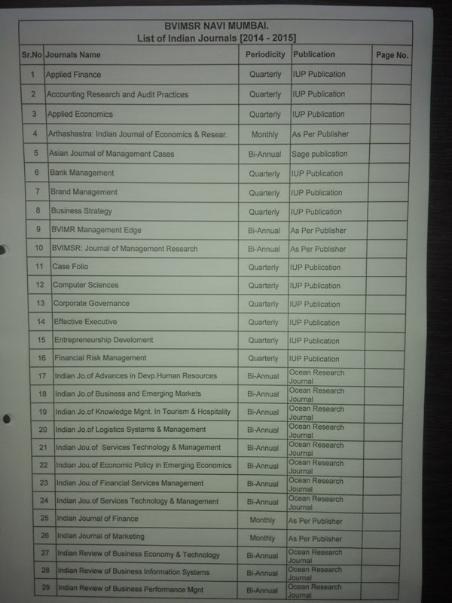

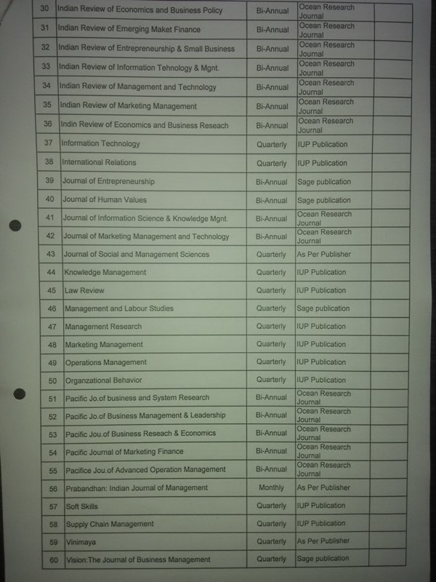

NOTE: - Online Journal Subscription Rupees 3, 79,397/-
[More than 1200 International Journals are covered]

List of Magazines (2014-2015)
List of Educational CD’S
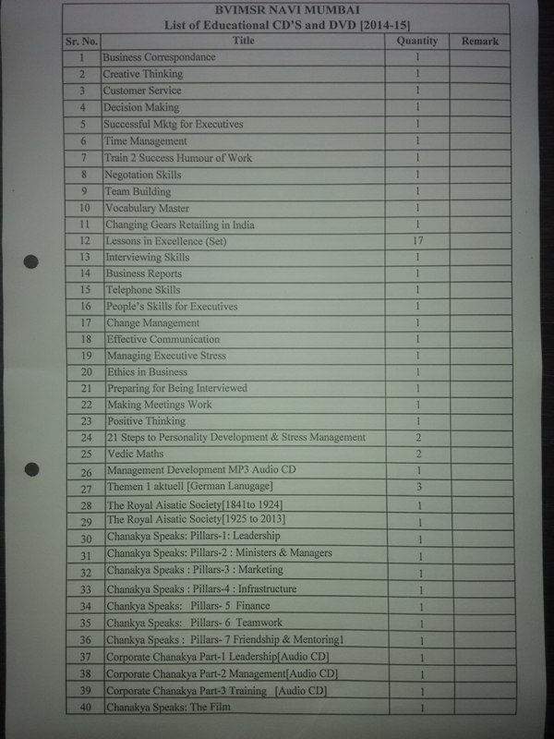

LIST OF NEWS PAPERS
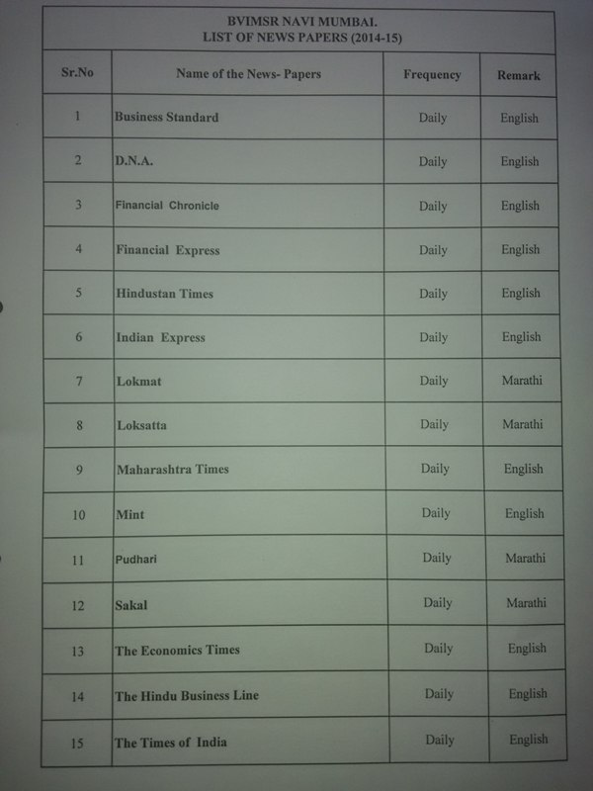

XV: Computer Facilities for the existing programme(s)
Sr. No. | Particulars | Requirements as per Norms (1:4 all undergraduate UG Programmes and 1:2 for MBA/MCA/PGDM/ PGDBM) |  | Availability
1. | No of Computer terminals | 184 |  | 184
2. | Hardware Specification | - |  | P IV-184
3. | No of terminals of LAN/WAN | - |  | All
4. | Relevant Legal Software | Application  04 | System  02
5. | Peripheral(s)/ Printers | 18
6. | Internet Accessibility (in kbps & hrs) |  |  | 16 MBPS lease line
XVI: Games and Sports Facilities

Outdoor sports: 2.5 acre sports ground
Cricket pitch, Cricket equipment like bats, balls, stumps, pads etc., Football, Volley ball court

Indoor sports: Table tennis table, racquets, balls, Carom board, Chess, Badminton, Cricket

Extra Curriculum Activities: Audio- Video competitions, Debate, Biz – Quiz, Extempore
Ad-Mad, Case Study analysis & presentations, Sports day, Cultural day, Fresher’s and farewell
party (Agman, Udaan), Alumni meet (Yaddein)

Orientation
It’s time to welcome the clear minds, pure hearts, true faith and ready hands. Our new students, who possess and opinion and a will, whose desires for power does not kill. Orientation programme at BVIMSR started on 8thAugust with full energy and enthusiasm with a variety of events held to orient and welcome new students. These events helped the students to understand the new surrounding and explore themselves to other co-curricular activities which involves experiential learning, team building, conflict management, time management and leadership all of which seek to guide in a holistic manner.

Shikhar – 2015:
Shikhar the most awaited event of BVIMSR an Annual Inter-College fest was held from 15-17 January. Started with various creative innovation activities, inviting students from other colleges. It’s a platform that encourages and boosts the talents of students from different management institutions. Shikhar includes more than 30 events on Indian Culture, Sports Activities and Academic Brilliance. It stands as a prominent event of BVIMSR where more than seventy colleges participated.
“Shikhar” started its footnote from the year 2002 and with time “Shikhar” has grown many folds. “Shikhar” was inaugurated by Mr. Intikhab Chaugule, Vice President of HSBC Bank along with Dr. D.Y.Patil, Director, BVIMSR.
The main attraction of Shikhar was the cultural night and battle bands. It was judged by the famous Choreographer Richard D’costa and Kiran Roy.

Alumni Meet (Yadeein):
Alumni Meet was organized on 7th March with an object of developing network and bonding with past students. It is an opportunity to bond with passed-out students, faculties and batch-mates in nostalgic environment.

Udaan (Farewell):
This was the farewell party given to senior students of MMS & PGDBM by their juniors. It was not just to bid good-bye, but to wish them good luck and happiness in their career and future.

Campus to Corporate Training Programme (CTC)
Campus-to-Corporate programme is organized every year to initiate students with corporate skills and to enhance the employability in the corporate world. Eminent speakers from the corporate with specialized knowledge and sectors are invited to deliver lectures. Areas like interview skills, business new analysis, general knowledge and various employability skills are covered.

International Conference
International Conference stands out as a memorable conference where research papers are presented and published. This year it was organized on 9th & 10th April, where in many industry experts and researchers contributed.

XVII: LEARNING PROCEDURE
The process is unique at BVIMSR. Apart from classroom sessions, we believe in special training
to cater to corporate needs. This involves providing the basic know-how of the day-to-day
happening in the industry and the same is supported by weekly update of the market.

Live projects have molded students in bringing the gap between theoretical knowledge and
practical learning. Working as a team in analyzing the issues has been rooted well into them by
giving live case studies.

Students have also been given opportunity to interact with the industry where the students go on
the field understanding the different nuances of the economy. Students also arrange seminars
under the guidance of the faculty in the functional areas of Management.

We at BVIMSR believe more in training, which involves inviting people from the industry who
have practical exposure which helps in grooming the students to become future managers.

XVIII: Curricula and syllabi for each of the programmes as approved by the University:
The Syllabus of Master of Management Studies (MMS)

Semester I
- Perspective Management
- Business Communication and Management Information Systems
- Organizational Behaviour
- Financial Accounting
- Operations Management
- Marketing Management
- Managerial Economics
- Business Statistics

Semester II
- Cost & Management Accounting
- Financial Management
- Operations Research
- Human Resources Management
- Legal Aspects of Business & Taxation
- Business Research Methods
- Elective Specialization Subject – I
- Elective Specialization Subject – II

Semester III
Common Subjects

- International Business
- Strategic Management
- Elective Specialization Subject – I
- Elective Specialization Subject – II
- Summer Internship

Core Specialisation Subjects:

Marketing | Finance | Human Resources | Operations | Systems
Product & Brand Management | Advanced Financial Management | Organizational Theories, Structure & Design | Advanced Supply Chain Management | Software Engineering
Sales Management & Sales Promotion | Security Analysis & Portfolio Management | Competency based HRM | Materials Management & Transportation | Business Intelligence and Analytics
Consumer & Industrial Buyer Behaviour | Corporate Valuation | Employee Relations & Labour Laws | Business Process Re-engineering and Benchmarking | Enterprise Resource Planning
Financial Aspects of Marketing | Corporate Law | Training & Development | Manufacturing Resource Planning & Control | Knowledge Management

Semester IV

Common Subjects:
- Management Control Systems
- Creativity & Innovation Management
- Elective Specialization Subject – I
- Elective Specialization Subject – II
- Industry Oriented Dissertation Project

Core Specialization Subjects:

Marketing | Finance | Human Resources | Operations | Systems
Strategic Marketing Management | Financial Modeling | Management of Change | Strategic Operations Management | Project Management
Integrated Marketing Communications & Digital Marketing | Mergers Acquisition & Corporate Restructuring | Strategic Human Resource Management | Project Management | IT Infrastructure Management

XIX: Academic Calendar- 2015-2016

Bharathi Vidyapeeth's Institute of Management Studies & Research
Academic Calendar : 2015-2016

Date | Day | Particular
13th July 2015 | Monday | III Semester Starts
14th July 2015 | Tuesday
15th July 2015 | Wednesday
16th July 2015 | Thursday
17th July 2015 | Friday
18th July 2015 | Saturday | Ramzan ID (Holiday)
19th July 2015 | Sunday
20th July 2015 | Monday
21st July 2015 | Tuesday
22nd July 2015 | Wednesday
23rd July 2015 | Thursday
24th July 2015 | Friday
25th July 2015 | Saturday | Visiting Faculty Meet
26th July 2015 | Sunday
27th July 2015 | Monday
28th July 2015 | Tuesday
29th July 2015 | Wednesday
30th July 2015 | Thursday
31st July 2015 | Friday
1st August 2015 | Saturday
2nd August 2015 | Sunday
3rd August 2015 | Monday
4th August 2015 | Tuesday | Orientation Programme Day 1 (Junior)
5th August 2015 | Wednesday | Orientation Programme Day 2 (Junior)
6th August 2015 | Thursday | Class Commencement (MMS Junior)
7th August 2015 | Friday
8th August 2015 | Saturday
9th August 2015 | Sunday
10th August 2015 | Monday
11th August 2015 | Tuesday | Orientation Programme Day 1 (Junior)
12th August 2015 | Wednesday | Orientation Programme Day 2 (Junior)
13th August 2015 | Thursday | Class Commencement (PGDBM Junior)
14th August 2015 | Friday
15th August 2015 | Saturday | Independence Day (Holiday)
16th August 2015 | Sunday
17th August 2015 | Monday
18th August 2015 | Tuesday
19th August 2015 | Wednesday
20th August 2015 | Thursday
21st August 2015 | Friday
22nd August 2015 | Saturday | Fresher's Party
23rd August 2015 | Sunday
24th August 2015 | Monday
25th August 2015 | Tuesday
26th August 2015 | Wednesday
27th August 2015 | Thursday
28th August 2015 | Friday | Traditional Day
29th August 2015 | Saturday | Student's Activity conducted by Core Faculty
30th August 2015 | Sunday
31st August 2015 | Monday
1st September 2015 | Tuesday
2nd September 2015 | Wednesday
3rd September 2015 | Thursday
4th September 2015 | Friday
5th September 2015 | Saturday | Dahikala (Half Day)
6th September 2015 | Sunday
7th September 2015 | Monday | Excel Training (Senior)
8th September 2015 | Tuesday | Excel Training (Senior)
9th September 2015 | Wednesday
10th September 2015 | Thursday
11th September 2015 | Friday
12th September 2015 | Saturday | Student's Activity conducted by Core Faculty
13th September 2015 | Sunday
14th September 2015 | Monday | Excel Training (Senior)
15th September 2015 | Tuesday | Excel Training (Senior)
16th September 2015 | Wednesday
17th September 2015 | Thursday | Ganesh Chaturthi (Holiday)
18th September 2015 | Friday
19th September 2015 | Saturday | Student's Activity conducted by Core Faculty
20th September 2015 | Sunday
21st September 2015 | Monday
22nd September 2015 | Tuesday
23rd September 2015 | Wednesday
24th September 2015 | Thursday
25th September 2015 | Friday | Id-Ul-Zuha (Holiday)
26th September 2015 | Saturday | Summer Project Viva - Finance Senior
27th September 2015 | Sunday | Anant Chaturdashi
28th September 2015 | Monday
29th September 2015 | Tuesday
30th September 2015 | Wednesday
1st October 2015 | Thursday
2nd October 2015 | Friday | Gandhi Jayanti (Holiday)
3rd October 2015 | Saturday | Student's Activity conducted by Core Faculty
4th October 2015 | Sunday
5th October 2015 | Monday
6th October 2015 | Tuesday
7th October 2015 | Wednesday
8th October 2015 | Thursday
9th October 2015 | Friday
10th October 2015 | Saturday | Summer Project Viva - HR, Marketing, Operations Senior
11th October 2015 | Sunday
12th October 2015 | Monday
13th October 2015 | Tuesday
14th October 2015 | Wednesday
15th October 2015 | Thursday
16th October 2015 | Friday
17th October 2015 | Saturday | Student's Activity conducted by Core Faculty
18th October 2015 | Sunday
19th October 2015 | Monday
20th October 2015 | Tuesday
21st October 2015 | Wednesday
22nd October 2015 | Thursday | Dassera (Holiday)
23rd October 2015 | Friday
24th October 2015 | Saturday
25th October 2015 | Sunday
26th October 2015 | Monday | Exam - Semester III
27th October 2015 | Tuesday | Exam - Semester III
28th October 2015 | Wednesday | Exam - Semester III
29th October 2015 | Thursday | Exam - Semester III
30th October 2015 | Friday | Exam - Semester III
31st October 2015 | Saturday | Exam - Semester III
1st November 2015 | Sunday | Exam - Semester III
2nd November 2015 | Monday | Exam - Semester III
3rd November 2015 | Tuesday | Exam - Semester III
4th November 2015 | Wednesday | Exam - Semester III
5th November 2015 | Thursday | Exam - Semester III
6th November 2015 | Friday | Exam - Semester III
7th November 2015 | Saturday
8th November 2015 | Sunday
9th November 2015 | Monday | Diwali Vacation
10th November 2015 | Tuesday | Diwali Vacation
11th November 2015 | Wednesday | Diwali Vacation
12th November 2015 | Thursday | Diwali Vacation
13th November 2015 | Friday | Diwali Vacation
14th November 2015 | Saturday | Diwali Vacation
15th November 2015 | Sunday
16th November 2015 | Monday | College Commencement - Senior
17th November 2015 | Tuesday
18th November 2015 | Wednesday
19th November 2015 | Thursday | Guest Lecture
20th November 2015 | Friday
21st November 2015 | Saturday | College Commencement - Junior
22nd November 2015 | Sunday
23rd November 2015 | Monday
24th November 2015 | Tuesday
25th November 2015 | Wednesday | Guru Nanak Jayanti (Holiday)
26th November 2015 | Thursday
27th November 2015 | Friday | Exam - Semester I
28th November 2015 | Saturday | Exam - Semester I
29th November 2015 | Sunday | Exam - Semester I
30th November 2015 | Monday | Exam - Semester I
1st December 2015 | Tuesday | Exam - Semester I
2nd December 2015 | Wednesday | Exam - Semester I
3rd December 2015 | Thursday | Exam - Semester I
4th December 2015 | Friday | Exam - Semester I
5th December 2015 | Saturday | Exam - Semester I
6th December 2015 | Sunday | Exam - Semester I
7th December 2015 | Monday | Exam - Semester I
8th December 2015 | Tuesday | Exam - Semester I
9th December 2015 | Wednesday | Exam - Semester I
10th December 2015 | Thursday | Exam - Semester I
11th December 2015 | Friday
12th December 2015 | Saturday | Alumni Meet
13th December 2015 | Sunday
14th December 2015 | Monday | Campus to Corporate (C2C) - Senior
15th December 2015 | Tuesday | Campus to Corporate (C2C) - Senior
16th December 2015 | Wednesday | Campus to Corporate (C2C) - Senior
17th December 2015 | Thursday | Campus to Corporate (C2C) - Senior
18th December 2015 | Friday
19th December 2015 | Saturday
20th December 2015 | Sunday
21st December 2015 | Monday | Winter Vacation
22nd December 2015 | Tuesday | Winter Vacation
23rd December 2015 | Wednesday | Winter Vacation
24th December 2015 | Thursday | Winter Vacation
25th December 2015 | Friday | Winter Vacation
26th December 2015 | Saturday | Winter Vacation
27th December 2015 | Sunday | Winter Vacation
28th December 2015 | Monday | Winter Vacation
29th December 2015 | Tuesday | Winter Vacation
30th December 2015 | Wednesday | Winter Vacation
31st December 2015 | Thursday | Winter Vacation
1st January 2016 | Friday | Winter Vacation
2nd January 2016 | Saturday | Winter Vacation
3rd January 2016 | Sunday | Winter Vacation
4th January 2016 | Monday | College Reopen
5th January 2016 | Tuesday
6th January 2016 | Wednesday
7th January 2016 | Thursday
8th January 2016 | Friday | General Knowledge Test
9th January 2016 | Saturday | Student's Activity conducted by Core Faculty
10th January 2016 | Sunday
11th January 2016 | Monday
12th January 2016 | Tuesday
13th January 2016 | Wednesday | Blood Donation Camp
14th January 2016 | Thursday
15th January 2016 | Friday | Parsi New Year (Holiday)
16th January 2016 | Saturday | Student's Activity conducted by Core Faculty
17th January 2016 | Sunday
18th January 2016 | Monday
19th January 2016 | Tuesday
20th January 2016 | Wednesday
21st January 2016 | Thursday | Intercollegiate Festival (Shikhar)
22nd January 2016 | Friday | Intercollegiate Festival (Shikhar)
23rd January 2016 | Saturday | Intercollegiate Festival (Shikhar)
24th January 2016 | Sunday
25th January 2016 | Monday
26th January 2016 | Tuesday | Republic Day (Holiday)
27th January 2016 | Wednesday
28th January 2016 | Thursday
29th January 2016 | Friday
30th January 2016 | Saturday | Ph.D. Induction Session
31st January 2016 | Sunday
1st February 2016 | Monday
2nd February 2016 | Tuesday
3rd February 2016 | Wednesday
4th February 2016 | Thursday
5th February 2016 | Friday
6th February 2016 | Saturday | Student's Activity conducted by Core Faculty
7th February 2016 | Sunday
8th February 2016 | Monday | Campus to Corporate (C2C) - Junior
9th February 2016 | Tuesday
10th February 2016 | Wednesday
11th February 2016 | Thursday
12th February 2016 | Friday
13th February 2016 | Saturday | Student's Activity conducted by Core Faculty
14th February 2016 | Sunday
15th February 2016 | Monday | Campus to Corporate (C2C) - Junior
16th February 2016 | Tuesday
17th February 2016 | Wednesday
18th February 2016 | Thursday | Campus to Corporate (C2C) - Junior
19th February 2016 | Friday | Shivaji Maharaj Jayanti (Holiday)
20th February 2016 | Saturday | Student's Activity conducted by Core Faculty
21st February 2016 | Sunday
22nd February 2016 | Monday | Exam - Semester IV
23rd February 2016 | Tuesday | Exam - Semester IV
24th February 2016 | Wednesday | Exam - Semester IV
25th February 2016 | Thursday | Exam - Semester IV
26th February 2016 | Friday | Exam - Semester IV
27th February 2016 | Saturday | Exam - Semester IV
28th February 2016 | Sunday
29th February 2016 | Monday | Exam - Semester IV
1st March 2016 | Tuesday | Exam - Semester IV
2nd March 2016 | Wednesday | Exam - Semester IV
3rd March 2016 | Thursday | Farewell Party (Udaan)
4th March 2016 | Friday
5th March 2016 | Saturday | Student's Activity conducted by Core Faculty
6th March 2016 | Sunday
7th March 2016 | Monday | Mahashivratri (Holiday)
8th March 2016 | Tuesday | Excel Training (Junior)
9th March 2016 | Wednesday | Excel Training (Junior)
10th March 2016 | Thursday
11th March 2016 | Friday
12th March 2016 | Saturday | Student's Activity conducted by Core Faculty
13th March 2016 | Sunday
14th March 2016 | Monday | Campus to Corporate (C2C) - Junior
15th March 2016 | Tuesday
16th March 2016 | Wednesday
17th March 2016 | Thursday
18th March 2016 | Friday
19th March 2016 | Saturday | Student's Activity conducted by Core Faculty
20th March 2016 | Sunday
21st March 2016 | Monday | Campus to Corporate (C2C) - Junior
22nd March 2016 | Tuesday
23rd March 2016 | Wednesday
24th March 2016 | Thursday | Dhulivandan (Holiday)
25th March 2016 | Friday | Good Friday (Holiday)
26th March 2016 | Saturday | Student's Activity conducted by Core Faculty
27th March 2016 | Sunday
28th March 2016 | Monday | Excel Training (Junior)
29th March 2016 | Tuesday | Excel Training (Junior)
30th March 2016 | Wednesday
31st March 2016 | Thursday
1st April 2016 | Friday
2nd April 2016 | Saturday
3rd April 2016 | Sunday
4th April 2016 | Monday
5th April 2016 | Tuesday
6th April 2016 | Wednesday
7th April 2016 | Thursday
8th April 2016 | Friday | Gudipadawa (Holiday)
9th April 2016 | Saturday
10th April 2016 | Sunday
11th April 2016 | Monday
12th April 2016 | Tuesday | Exam - Semester II
13th April 2016 | Wednesday | Exam - Semester II
14th April 2016 | Thursday | Dr. Babasaheb Ambedkar Jayanti (Holiday)
15th April 2016 | Friday | Exam - Semester II
16th April 2016 | Saturday | Exam - Semester II
17th April 2016 | Sunday | Exam - Semester II
18th April 2016 | Monday | Exam - Semester II
19th April 2016 | Tuesday | Mahavir Jayanti (Holiday)
20th April 2016 | Wednesday | Exam - Semester II
21st April 2016 | Thursday | Exam - Semester II
22nd April 2016 | Friday | Exam - Semester II
23rd April 2016 | Saturday | Exam - Semester II
24th April 2016 | Sunday | Exam - Semester II
25th April 2016 | Monday | Exam - Semester II
26th April 2016 | Tuesday | Exam - Semester II
27th April 2016 | Wednesday | Exam - Semester II
28th April 2016 | Thursday | Exam - Semester II
29th April 2016 | Friday
30th April 2016 | Saturday
1st May 2016 | Sunday | Maharashtra Day
2nd May 2016 to 30th June 2016 |  | Summer Internship - Junior

